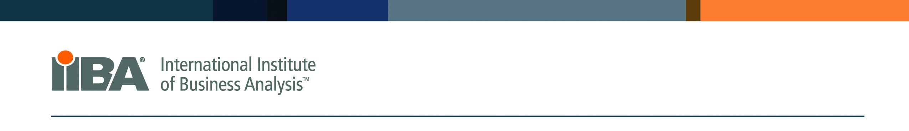

International Institute of Business Analysis


2024 Spring BABOK Study Group Sign-Up Form
Start Day/Date: Tuesday, April 23
End Day/Date: Tuesday, August 27

Contact Information:

Name: ____________________________________________________________________________

Employer: __________________________________ Title: ______________________________

Email: _____________________________________________________________________________

Alternate Email: ____________________________________________________________________

IIBA number: _____________________________ (You must have an IIBA number by the time the Study Group starts)

Number of years of Business Analysis experience: ______

Certification you will be seeking: _______________________________________ (“Not Sure” is an acceptable reply)

CBAP – Certified Business Analysis Professional

CCBA – Certified of Capability in Business Analysis (0 – 2 Years of Business Analysis Experience)

ECBA – Entry Certificate in Business Analysis (2 – 5 Years of Business Analysis Experience)

Not Sure or Not Seeking Certification (Over 5 Years of Business Analysis Experience)

Payment Information:
Please pay for your $75 participant fee via the PayPal link on our website:
Join our BABOK Study Group | IIBA Sacramento

A special thanks to our sponsors!



